Spring JDBC的依賴注入(Dependency Injection)
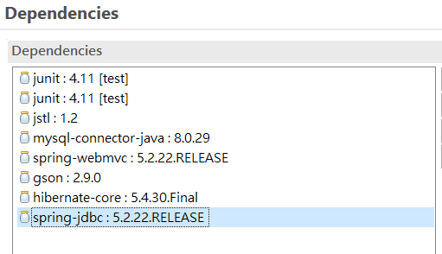
<dependency>
<groupId>javax.servlet</groupId>
<artifactId>jstl</artifactId>
<version>1.2</version>
</dependency>
<dependency>
<groupId>mysql</groupId>
<artifactId>mysql-connector-java</artifactId>
<version>8.0.29</version>
</dependency>
<dependency>
<groupId>org.springframework</groupId>
<artifactId>spring-webmvc</artifactId>
<version>5.2.22.RELEASE</version>
</dependency>
<dependency>
<groupId>com.google.code.gson</groupId>
<artifactId>gson</artifactId>
<version>2.9.0</version>
</dependency>
<dependency>
<groupId>org.springframework</groupId>
<artifactId>spring-jdbc</artifactId>
<version>5.2.22.RELEASE</version>
</dependency>
文件：
- applicationContext.xml (bean 屬性設定檔案)
- Coffee.java , CoffeeDAO.java (Model)
- Spring Controller
- src/main/applicationContext.xml
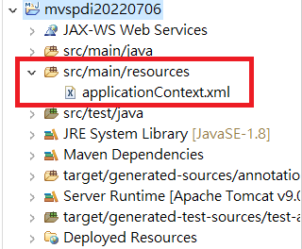
<?xml version="1.0" encoding="UTF-8"?>
<beans xmlns="http://www.springframework.org/schema/beans"
xmlns:xsi="http://www.w3.org/2001/XMLSchema-instance"
xmlns:p="http://www.springframework.org/schema/p"
xsi:schemaLocation="http://www.springframework.org/schema/beans
http://www.springframework.org/schema/beans/spring-beans-3.0.xsd">

<bean id="ds" class="org.springframework.jdbc.datasource.DriverManagerDataSource">
<property name="driverClassName" value="com.mysql.cj.jdbc.Driver" />
<property name="url" value="jdbc:mysql://localhost:3306/classicmodels?serverTimezone=Asia/Taipei" />
<property name="username" value="root" />
<property name="password" value="1234" />
</bean>

<bean id="myTemplate" class="org.springframework.jdbc.core.JdbcTemplate">
<property name="dataSource" ref="ds"></property>
</bean>

<bean id="cfdao" class="model.CoffeeDAO">
</bean>

</beans>

Model Coffee.java CoffeeDAO.java

package model;
public class Coffee implements java.io.Serializable {
private String cofName;
private int supId;
private double price;
private int sales;
private int total;
public Coffee() {
}
public Coffee(String cofName, int supId, double price, int sales, int total) {
this.cofName = cofName;
this.supId = supId;
this.price = price;
this.sales = sales;
this.total = total;
}
public String getCofName() {
return this.cofName;
}
public void setCofName(String cofName) {
this.cofName = cofName;
}
public int getSupId() {
return this.supId;
}

public void setSupId(int supId) {
this.supId = supId;
}

public double getPrice() {
return this.price;
}

public void setPrice(double price) {
this.price = price;
}

public int getSales() {
return this.sales;
}

public void setSales(int sales) {
this.sales = sales;
}

public int getTotal() {
return this.total;
}

public void setTotal(int total) {
this.total = total;
}

}

CoffeeDAO:
package model;

import java.sql.ResultSet;
import java.sql.SQLException;
import java.util.ArrayList;
import java.util.List;
import org.springframework.dao.DataAccessException;
import org.springframework.jdbc.core.JdbcTemplate;
import org.springframework.jdbc.core.ResultSetExtractor;
import org.springframework.jdbc.core.RowMapper;

public class CoffeeDAO {
private JdbcTemplate template;

public void setTemplate(JdbcTemplate template) {
this.template = template;
}

public List<Coffee> getAllEmployeesRowMapper(){
return template.query("select * from classicmodels.Coffees",new RowMapper<Coffee>(){
@Override
public Coffee mapRow(ResultSet rs, int rownumber) throws SQLException {
Coffee c=new Coffee();
c.setCofName(rs.getString("cof_Name"));
c.setSupId(rs.getInt("SUP_ID"));
c.setPrice(rs.getDouble("price"));
c.setSales(rs.getInt("sales"));
c.setTotal(rs.getInt("total"));
return c;
}
});
}
}

Controller:

import java.util.List;

import org.springframework.context.ApplicationContext;
import org.springframework.context.support.ClassPathXmlApplicationContext;
import org.springframework.jdbc.core.JdbcTemplate;
import org.springframework.stereotype.Controller;
import org.springframework.ui.ModelMap;
import org.springframework.web.bind.annotation.RequestMapping;
import org.springframework.web.bind.annotation.RequestMethod;

import model.Coffee;
import model.CoffeeDAO;

@Controller
public class CoffeeController {
@RequestMapping(value = "/cfjdbc",method = RequestMethod.GET)
public String spJdbc(ModelMap model) {

ApplicationContext ctx=new ClassPathXmlApplicationContext("applicationContext.xml");
CoffeeDAO dao=(CoffeeDAO)ctx.getBean("cfdao");
JdbcTemplate tm=(JdbcTemplate)ctx.getBean("myTemplate");
dao.setTemplate(tm);
List<Coffee> list=dao.getAllEmployeesRowMapper();

model.addAttribute("coffees", list);
return "coffee";
}
}

Coffee View
<%@ page language="java" contentType="text/html; charset=UTF-8"
pageEncoding="UTF-8"%>
<%@taglib prefix="c" uri="http://java.sun.com/jsp/jstl/core"%>
<!DOCTYPE html>
<html>
<head>
<meta charset="UTF-8">
<title>Tables</title>
</head>
<body>
<table border="1" width="70%">
<tr>
<th>Coffee Name</th>
<th>Sales</th>
<th>Total</th>
<th>Price</th>

</tr>
<c:forEach var="current" items="${coffees}" >
<tr>
<td><c:out value="${current.cofName}" /></td>
<td><c:out value="${current.sales}" /></td>
<td><c:out value="${current.total}" /></td>
<td><c:out value="${current.price}" /></td>
</tr>
</c:forEach>
</table>

</body>

</html>

